PROJECT DEVELOPMENT - DELIVERY OF SPRINT 1
Date: | 09 November 2022
Team ID: | PNT2022TMID00966
Name: | Real-Time River Water Quality Monitoring and Control System

Coding for sprint 1:

Login.html

<html>
<head>
<meta charset="UTF-8">
<title> Login </title>
<link rel="stylesheet" href="{{ url_for('static', filename='style.css') }}">
</head>
<body></br></br></br></br></br>
<div align="center">
<div align="center" class="border">
<div class="header">
<h1 class="word">Login</h1>
</div></br></br></br>
<h2 class="word">
<form action="{{ url_for('login') }}"

method="post">

<div class="msg">{{ msg }}</div>
<input id="username" name="username"

type="text" placeholder="Enter Your Username" class="textbox"/></br></br>
<input id="password" name="password" type="password" placeholder="Enter Your Password" class="textbox"/></br></br></br>
<input type="submit" class="btn" value="Sign
In"></br></br>
</form>
</h2>
<p class="bottom">Don't have an account? <a class="bottom" href="{{url_for('register')}}"> Sign Up here</a></p>
</div>
</div>
</body>
</html>

Register.html

<html>

<head>
<meta charset="UTF-8">
<title> Register </title>
<link rel="stylesheet" href="{{ url_for('static', filename='style.css') }}">
</head>
<body></br></br></br></br></br>
<div align="center">
<div align="center" class="border">
<div class="header">
<h1 class="word">Register</h1>
</div></br></br></br>
<h2 class="word">
<form action="{{ url_for('register') }}"

method="post">

<div class="msg">{{ msg }}</div>
<input id="username" name="username"

type="text" placeholder="Enter Your Username" class="textbox"/></br></br>
<input id="password" name="password" type="password" placeholder="Enter Your Password" class="textbox"/></br></br>
<input id="email" name="email" type="text" placeholder="Enter Your Email ID" class="textbox"/></br></br>
<input type="submit" class="btn" value="Sign

Up"></br>

</form>
</h2>
<p class="bottom">Already have an account? <a

class="bottom" href="{{url_for('login')}}"> Sign In here</a></p>
</div>
</div>
</body>
</html>

Style.css

.header{
padding: 5px 120px; width: 150px; height: 70px;
background-color: #236B8E;
}

.border{
padding: 80px 50px; width: 400px; height: 450px;

border: 1px solid #236B8E; border-radius: 0px; background-color: #9AC0CD;
}

.btn {
padding: 10px 40px; background-color: #236B8E; color: #FFFFFF;
font-style: oblique; font-weight: bold; border-radius: 10px;
}

.textbox{
padding: 10px 40px; background-color: #236B8E; text-color: #FFFFFF; border-radius: 10px;
}

::placeholder { color: #FFFFFF; opacity: 1;
font-style: oblique;
font-weight: bold;
}

.word{
color: #FFFFFF;
font-style: oblique;
font-weight: bold;
}

.bottom{
color: #236B8E;
font-style: oblique;
font-weight: bold;
}

Output: login page

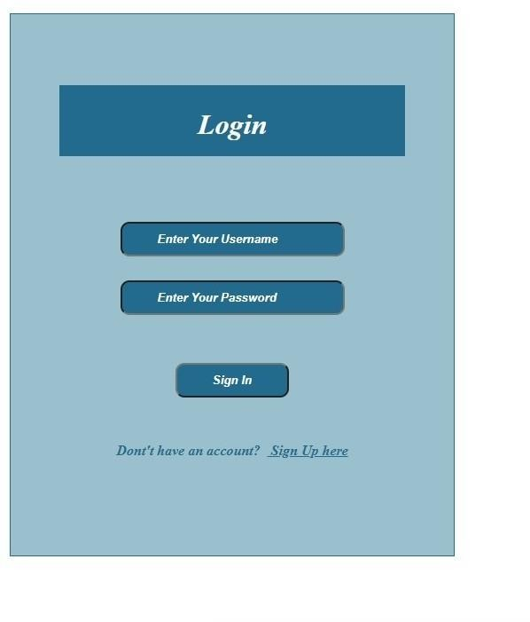

Registration page:

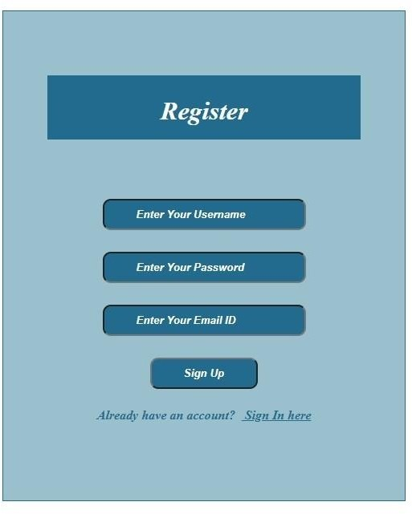

Registration successful page:

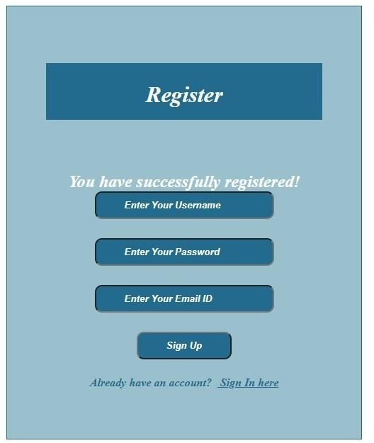

Index page:

